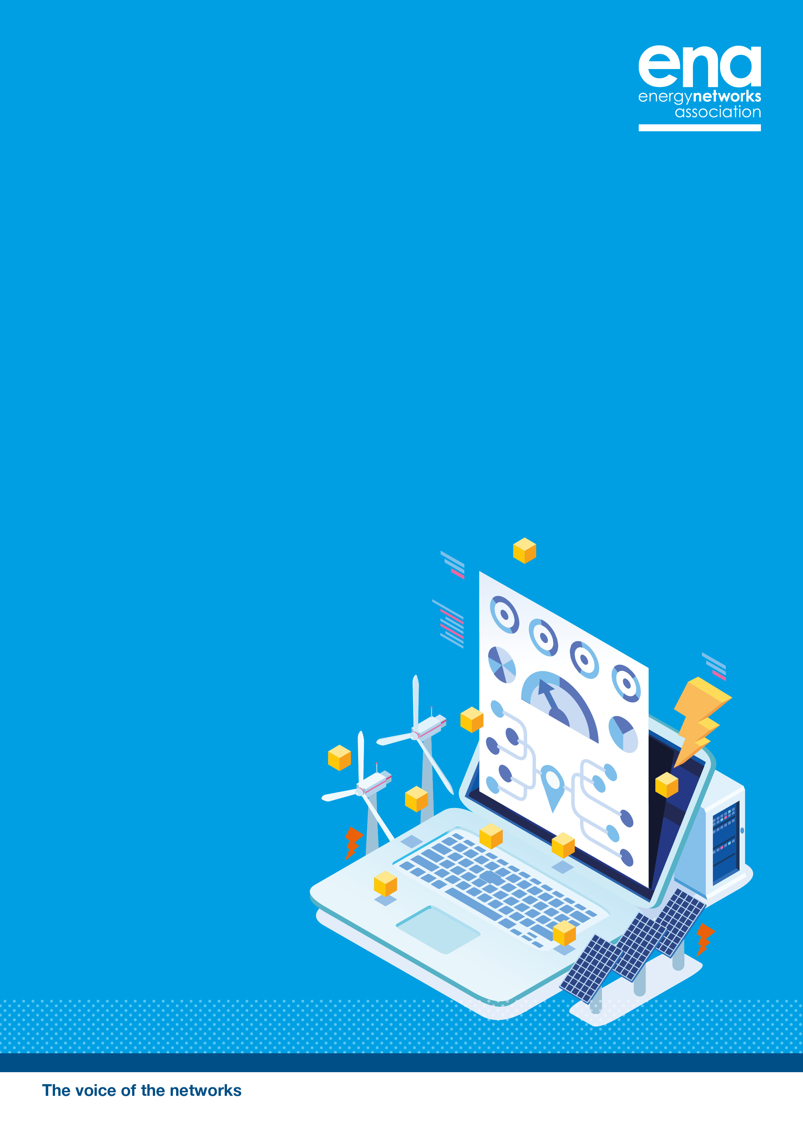

Energy
Networks
Innovation
Process
NIA Project Registration and PEA Document
Date of Submission:

NIA Project Registration
and PEA Document

Notes on Completion: Please refer to the NIA Governance Document to assist in the completion of this form. Please use the default font (Calibri font size 10) in your submission. Please ensure all content is contained within the boundaries of the text areas. The full-completed submission should not exceed 10/12 pages in total.

- Project Registration
Project Title (This cannot be changed once registered) |  | Project Reference
Funding Licensee(s) |  | Project Start Date
Nominated Project Contact(s) |  | Project Duration
Contact Email Address |  | Project Budget
Project Summary (125 words limit)

Lead Sector
Electricity Distribution | Gas Distribution
Electricity Transmission | Gas Transmission

Other Sectors
Electricity Distribution | Gas Distribution
Electricity Transmission | Gas Transmission

Research Area
Net zero and the energy system transition | Optimised assets and practices
Flexibility and Commercial Evolution | Whole Energy System
Consumer Vulnerability | Energy System Transition

Development steps
Technology Readiness Level (TRL) at Start | TRL at Completion

- Project Details
  - Problem(s)
This should outline the Problem(s) which is/are being addressed by the Project. This cannot be changed once registered.

  - Method(s)
This section should set out the Method or Methods that will be used in order to provide a Solution to the Problem. The type of Method should be identified where possible, eg technical or commercial.
For RIIO-2 projects, apart from projects involving specific novel commercial arrangement(s), this section should also include a Measurement Quality Statement and Data Quality Statement.

  - Scope
The scope and objectives of the Project should be clearly defined including the net benefits for consumers (eg financial, environmental, etc). This section should also detail the financial benefits which would directly accrue to the GB Gas Transportation System and/or electricity transmission or distribution.

  - Objectives
This cannot be changed once registered.

  - Consumer Vulnerability Impact Assessment (RIIO-2 projects only)
Details of the expected effects of the Method(s) and Solution(s) upon consumers in vulnerable situations. This must include an assessment of distributional impacts (technical, financial and wellbeing-related). For RIIO-1 projects please add “Not Applicable”

  - Success Criteria
Details of how the Funding Licensee will evaluate whether the Project has been successful. This cannot be changed once registered.

  - Project Partners and External Funding
Details of actual or potential Project Partners and external funding support as appropriate.

  - Potential for New Learning
Details of what the parties expect to learn and how the learning will be disseminated.

  - Scale of Project
The Funding Licensee should justify the scale of the Project – including the scale of the investment relative to the potential benefits. In particular, it should explain why there would be less potential for new learning if the Project were of a smaller scale.

  - Geographical Area
Details of where the Project will take place. If the Project is a collaboration, the Funding Licensee area(s) in which the Project will take place should be identified.

  - Relevant Foreground IPR
Details of expected Relevant Foreground IPR which will be generated in the Project. If applicable, this must also explain if Background IPR will be required to use the Relevant Foreground IPR.

  - Data Access Details
A description of how any data (de-sensitised where necessary) that are expected to be gathered in the course of the project can be requested by interested parties, and, if applicable, reasons why such data cannot be released to interested parties. This requirement may be met by including a link to the publicly available data sharing policy, which is required by virtue of paragraphs 2.13-2.16 of the RIIO-2 NIA Governance Document.

  - Revenue allowed for in the current RIIO settlement
An indication of the funding provided to the network licensee within the current RIIO settlement that is likely to be surplus to requirements as a result of the Project.

  - Indicative Total NIA Project Expenditure
An indication of the total Allowable NIA Expenditure that the Funding Licensee expects to reclaim for the whole of the Project (RIIO1).
An indication of the Total NIA Expenditure that the Funding Licensee expects to reclaim for the whole of the Project (RIIO2).

- Project Eligibility Assessment
There are slightly differing requirements for RIIO-1 and RIIO-2 NIA projects. This is noted in each case, with the requirement numbers listed for both where they differ (shown as RIIO-2 / RIIO-1).
  - Requirement 1 - facilitate the energy system transition and/or benefit consumers in vulnerable situations (Please complete sections 3.1.1 and 3.1.2 for RIIO-2 projects only)
Please answer at least one of the following:
    - How the Project has the potential to facilitate the energy system transition:

    - How the Project has potential to benefit consumer in vulnerable situations:

  - Requirement 2 / 2b - has the potential to deliver net benefits to consumers
Project must have the potential to deliver a Solution that delivers a net benefit to consumers of the Gas Transporter and/or Electricity Transmission or Electricity Distribution licensee, as the context requires. This could include delivering a Solution at a lower cost than the most efficient Method currently in use on the GB Gas Transportation System, the Gas Transporter’s and/or Electricity Transmission or Electricity Distribution licensee’s network, or wider benefits, such as social or environmental.
    - Please provide an estimate of the saving if the Problem is solved (RIIO-1 projects only)

    - Please provide a calculation of the expected benefits the Solution
This is for Development or Demonstration Projects, not required for Research Projects. It should be (Base Cost – Method Cost, Against Agreed Baseline) and include a description of the recipients of the benefits.

    - Please provide an estimate of how replicable the Method is across GB
This must be in terms of the number of sites, the sort of site the Method could be applied to, or the percentage of the Network Licensees system where it could be rolled-out.

    - Please provide an outline of the costs of rolling out the Method across GB.

  - Requirement 3 / 1 – involve Research, Development or Demonstration
    - RIIO-1 Projects
A RIIO-1 NIA Project must have the potential to have a Direct Impact on a Network Licensee’s network or the operations of the System Operator and involve the Research, Development, or Demonstration of at least one of the following (please tick which applies):

A specific piece of new (i.e. unproven in GB, or where a Method has been trialled outside GB the Network Licensee must justify repeating it as part of a Project) equipment (including control and communications systems and software)
A specific novel arrangement or application of existing licensee equipment (including control and/or communications systems and/or software)
A specific novel operational practice directly related to the operation of the GB electricity transmission or distribution systems
A specific novel commercial arrangement

    - RIIO-2 Projects
A RIIO-2 Project must involve the Research, Development or Demonstration of at least one of the following:

A specific piece of new equipment (including monitoring, control and communications systems and software)
A specific piece of new technology (including analysis and modelling systems or software), in relation to which the Method is unproven
A new methodology (including the identification of specific new procedures or techniques used to identify, select, process, and analyse information)
A specific novel arrangement or application of existing gas transportation, electricity transmission or electricity distribution equipment, technology or methodology
A specific novel operational practice directly related to the operation of the GB Gas Transportation System, electricity transmission or electricity distribution
A specific novel commercial arrangement

  - Requirement 4 / 2a – develop new learning
A Project must develop new learning that can be applied by Gas Transporter and/or Electricity Transmission or Electricity Distribution licensees. For RIIO-1 Network Licensees may wish to address challenges specific to their network.
Please answer one of the following:
    - Please explain how the learning that will be generated could be used by relevant Network Licenses

    - Or, please describe what specific challenge identified in the Network Licensee’s innovation strategy is being addressed by the Project (RIIO-1 only)

    - Is the default intellectual Property Rights (IPR) position being applied?
This cannot be changed once registered.
Yes | No
If “no”, the following questions must be answered:

    - Demonstrate how the learning from the Project can be successfully disseminated to Network Licensees and other interested parties:

    - Describe how any potential constraints or costs caused, or resulting from, the imposed IPR arrangements:

    - Justify why the proposed IPR arrangements provide value for money for customers:

  - Requirement 5 / 2c – be innovative
A Project must be innovative (ie not a business as usual activity) and have an unproven business case entailing a degree of risk warranting a limited Research, Development or Demonstration Project to demonstrate its effectiveness. This could include Projects which are untested at scale, or in relation to which there are risks, which might prevent the widespread deployment of the equipment, technology or methodology.
    - Why is the project innovative?
RIIO-1 projects must include description of why they have not been tried before.

    - Why is the Network Licensee not funding the Project as part of its business as usual activities?

    - Why can the Project can only be undertaken with the support of NIA?
This must include a description of the specific risks (e.g. commercial, technical, operational or regulatory) associated with the Project.

  - Requirement 6 / 2d – not lead to unnecessary duplication
A Project must not lead to unnecessary duplication of any other Project, including but not limited to IFI, LCNF, NIA, NIC or SIF projects already registered, being carried out or completed.
    - Please demonstrate below that no unnecessary duplication will occur as a result of the Project.

    - If applicable, justify why you are undertaking a Project similar to those being carried out by any other Network Licensees.

- PEA approval
The senior person (RIIO-1) or senior network manager (RIIO-2) responsible for implementing RIIO-2 NIA Projects must approve the PEA. It must then be published on the Project Registration page of the Smarter Networks Portal.
Please confirm this project has been approved by a senior member of staff

